**Selling Ames Model Metrics:**

**Model Features:**

* SalePrice: The price which the house ultimately sells for. This is a fairly bottom-heavy class, as the mass market houses for somewhat less money is more abundant, the cheapest properties are not especially popular compared to those sold for prices between $100,000 and $200,000. This suggests that most buyers are willing to pay more for a slightly higher quality house, and below a certain threshold, will prefer to rent instead.
* 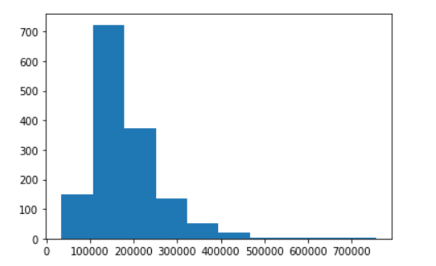
* OverallQual: This measures the overall quality of the house. It is a fairly tight variable, with the average coming very close to 5 out of ten, suggesting the metric is fitted to the standards that exist for all dwellings. It should also be noted that the distribution is tight enough that none of the histogram classes exceed 400 members, none has a share greater than 1/8 of the total 2930 observations.

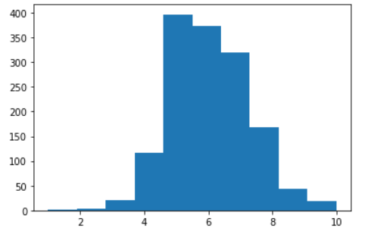

* YearBuilt: The year the dwelling was built. This class is notable for having an extreme positive skew, with the largest plurality being built after 2000, meanwhile the second coming from the 1960s to the 1980s. This suggests a growth in the housing market, as well as a broad demand for more recently built houses. However, the slightly older houses having some greater abundance over those built from 1980 until 2000 implies that either those houses were seen as less desirable and replaced with newer models, or that simply fewer houses were built in that timeframe. All of these ideas are consistent with the findings of the model.

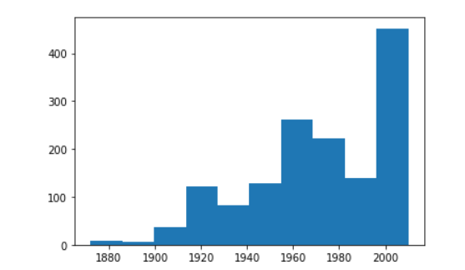

* YearRemodAdd**:** The year of the most recent remodel on the house. This is also heavily skewed, with remodels mainly occurring after 2000, and the remainder from the 1950s. This is heavily consistent with the model’s findings regarding this variable.



* Garage Area: This feature tracks the square footage of each house’s associated garage (those without garages are given areas of zero square feet). These are fairly average, with the largest class tending towards the center of observations. It does seem, per the model, that larger garages are attractive for potential buyers, as these edge cases are associated with higher sale prices more so than the square footage of their associated house. 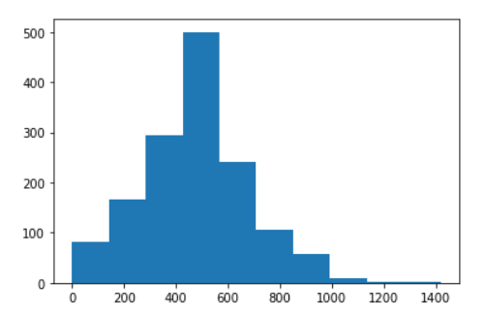
* Remodeled: This feature was made when the odd nature of the “yearremodadd” variable was noted. This is a “dummy” variable”, one where the values are set to one or zero depending on the condition. In this case, the condition is whether the remodel occurred before (0) or after (1) the year 2000. Around 60% were completed before 2000, while about 40% were completed in 2000 or after.

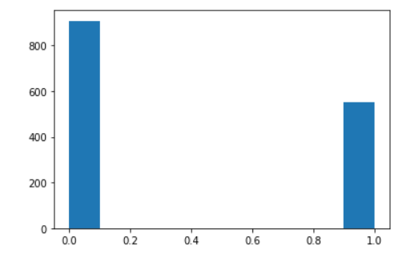

**Parameters:**